|  |  |
| --- | --- |
| Name: Sayyed Sohail Rashid | Course Name: DC-LAB |
| Class: BE-CO | Batch: 01 |
| Roll no: 18CO48 | Experiment No: 01 |

Aim : To implement the Client / Server using RPC.

Code:

Client.java

int a, b, c;

while (true) {

fun = receiveRead.readLine();

if (fun != null) {

System.out.println("Operation : " + fun);

}

a = Integer.parseInt(receiveRead.readLine());

System.out.println("Parameter 1 : " + a);

b = Integer.parseInt(receiveRead.readLine());

if (fun.compareTo("add") == 0) {

c = a + b;

c = a / b;

System.out.println("Division = " + c);

pwrite.println("Division = " + c);

}

System.out.flush();

}

Code:

Server.java

import java.io.*;

import java.net.*;

class cli {

public static void main(String[] args) throws Exception {

Socket sock = new Socket("127.0.0.1", 3000);

BufferedReader keyRead = new BufferedReader(new InputStreamReader(System.in));

OutputStream ostream = sock.getOutputStream();

PrintWriter pwrite = new PrintWriter(ostream, true);

InputStream istream = sock.getInputStream();

BufferedReader receiveRead = new BufferedReader(new InputStreamReader(istream));

System.out.println("Client ready, type and press Enter key");

String receiveMessage, sendMessage, temp;

while (true) {

System.out.println("\nEnter operation to perform(add,sub,mul,div)....");

temp = keyRead.readLine();

sendMessage = temp.toLowerCase();

pwrite.println(sendMessage);

System.out.println("Enter first parameter :");

sendMessage = keyRead.readLine();

pwrite.println(sendMessage);

System.out.println("Enter second parameter : ");

sendMessage = keyRead.readLine();

pwrite.println(sendMessage);

System.out.flush();

if ((receiveMessage = receiveRead.readLine()) != null) {

System.out.println(receiveMessage);

}

}

}

}

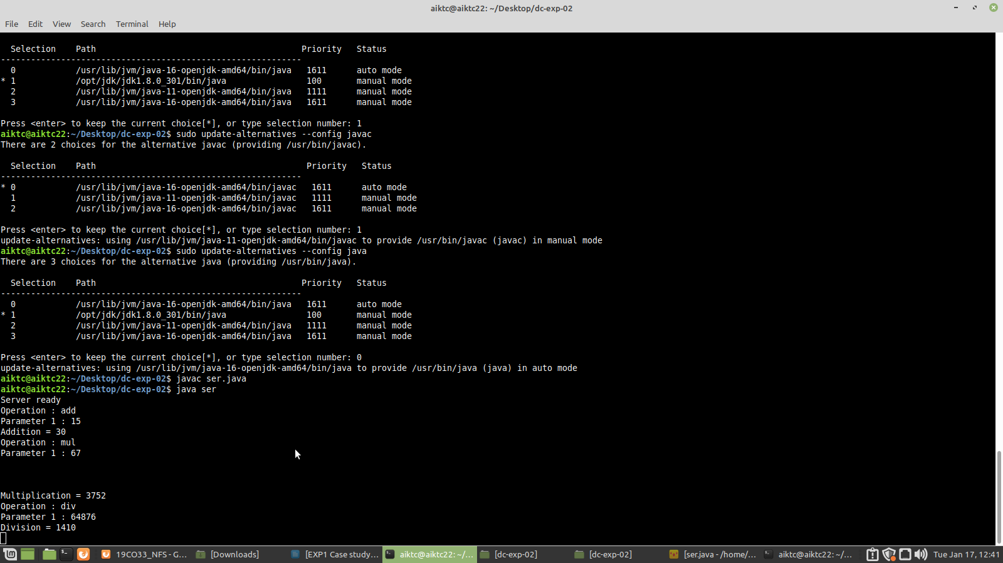

Conclusion:

We have successfully performed the experiment on client/server using RPC.